ArrayList Test 1

1. Which of the following is a reason to use an ArrayList instead of an array?
2. An ArrayList allows faster access to the kth item than array does.
3. An ArrayList always uses less memory than an array.
4. An ArrayList can store objects and an array can only store primitives.
5. An ArrayList resizes itself as necessary when items are added, but an array does not.

1. Which of the following will correctly instantiate an ArrayList of integer values?
2. List<Integer> list = new ArrayList<Integer>()
3. ArrayList<Integer> list = new ArrayList<Integer>()
4. List<int> list = new ArrayList<int>()
5. I only
6. II only
7. III only
8. I and II
9. Consider the following code segment.

ArrayList<String> items = new ArrayList<String> ();

items.add("A");

items.add("B");

items.add(0, "C");

items.add(0, "D");

items.remove(3);

items.add("E");

System.out.println(items);

What of the following represents items after the code above is executed?

1. [A, B, C, E]
2. [A, B, D, E]
3. [D, C, A, E]
4. [D, C, B, E]
5. Assume that an ArrayList of integers named **list** has been instantiated. What is output by the following code segment?

for (int k = 0; k < 10; k+=2)  
{  
 list.add(0, k);

}

for (int n : list)  
{  
 System.out.print(n + " ");  
}

1. 0 0 0 0 0
2. 0 2 4 6 8
3. 8 6 4 2 0
4. 0 2 4 6 8 10
5. Consider the following method that is intended to modify its parameter list by replacing all occurrences of name with newValue.

public void replace(ArrayList<String> list,   
 String name, String newValue)  
{  
 for (int j = 0; j < list.size(); j++)  
 {  
 if ( /* expression */ )  
 {  
 list.set(j, newValue);  
 }  
 }  
}

Which of the following can be used to replace /* expression */ so that replace works as  
 intended?

1. list.get(j) == name
2. list.get(j).equals(name)
3. list[j] == name
4. list[j].equals(name)

1. Consider the follow method.

public void mystery()

{

for(int i=0; i < list.size(); i++)

{

if(list.get(i) == 1)

list.remove(i);

}

}

Assume that an ArrayList of integers named **list** has been instantiated and initialized with the following Integer objects.

[0, 1, 0, 1, 1, 0, 1, 1, 0, 1];

Which of the following represents **list** after a call to mystery?

1. [0, 0, 0, 0]
2. [0, 1, 0, 1, 1, 0, 1, 1, 0, 1]
3. [0, 0, 1, 0, 1, 0]
4. [0, 0, 0]

**Questions 7-8 refer to the following two classes.**

public class Info   
{  
 private String name;

public Info(String n)   
 {   
 name = n;  
 }

public String getName()   
 {  
 return name;  
 }

public void setName(String n)   
 {  
 name = n;  
 }

}

public class Demo  
{  
 public static void main(String[] args)  
 {  
 ArrayList<Info> list= new ArrayList<Info>();  
  
 list.add(new Info("A"));  
 list.add(new Info("B"));  
 list.add(new Info("C"));  
 list.add(new Info("D"));

for (Info obj : list)  
 {  
 /* expression 1 */   
 }

}  
 }

1. Which of the following can replace /* expression 1 */ so that all of the Info objects in list have their name field assigned a value of "X"?
2. obj.setName("X")
3. obj = "X"
4. list[i].setName("X")
5. obj.getName().setName("X")
6. Which of the following **cannot** be added to the Demo class’s main method so that the entire ArrayList is printed displaying the name field of each Info object in list.
7. for (int k = 0; k < list.size(); k++)

{  
 System.out.println(list.get(k).getName());  
}

1. for (int k = 0; k < list.size(); k++)  
   {  
    Info obj = list.get(k);  
    System.out.println(obj);  
   }
2. for (Info obj : list)  
   {  
    System.out.println(obj.getName());  
   }
3. for (int k = 0; k < list.size(); k++)  
   {  
    Info obj = list.get(k);  
    System.out.println(obj.getName());  
   }

**Free Response**

A music Web site keeps track of downloaded music. For each download, the site uses a **DownloadInfo**

object to store a song's title and the number of times it has been downloaded. A partial declaration for the **DownloadInfo** class is shown below.

public class DownloadInfo

{

/** Creates a new instance with the given unique title and sets the

* number of times downloaded to 1.

* @param title the unique title of the downloaded song

*/

public DownloadInfo(String title)

{ /* implementation not shown */ }

/** @return the title */

public String getTitle()

{ /* implementation not shown */ }

/** Increment the number times downloaded by 1 */

public void incrementTimesDownloaded()

{ /* implementation not shown */ }

// There may be instance variables, constructors, and methods that are not shown

}

The list of downloaded information is stored in a **MusicDownloads** object. A partial declaration for the **MusicDownloads** class is shown below.

public class MusicDownloads

{

/** The list of downloaded information.

* Guaranteed not to be null and not to contain duplicate titles.

*/

private List<DownloadInfo> downloadList;

/** Creates the list of downloaded information. */

public MusicDownloads()

{ downloadList = new ArrayList<DownloadInfo>(); }

/** Returns a reference to the DownloadInfo object with the requested   
 title if it exists.

* @param title the requested title

* @return a reference to the DownloadInfo object with the

* title that matches the parameter title if it exists in the list;

* null otherwise.

* **Postcondition**:

* - no changes were made to downloadList.

*/

public DownloadInfo getDownloadInfo(String title)

{ /* to be implemented in part (a) */ }

/** Updates downloadList with information from titles.

* @param titles a list of song titles

* **Postcondition**:

* - there are no duplicate titles in downloadList.

* - no entries were removed from downloadList.

* - all songs in titles are represented in downloadList.

* - for each existing entry in downloadList, the download count is   
 * increased by the number of times its title appeared in titles.

* - the order of the existing entries in downloadList is not changed.

* - the first time an object with a title from titles is added to   
 * downloadList, it is added to the end of the list.

* - new entries in downloadList appear in the same order

* in which they first appear in titles.

* - for each new entry in downloadList, the download count is equal to

* the number of times its title appeared in titles.

*/

public void updateDownloads(List<String> titles)

{ /* to be implemented in part (b) */ }

// There may be instance variables, constructors, and methods that are not shown.

}

1. Write the MusicDownloads method getDownloadInfo, which returns a reference to a DownloadInfo object if an object with a title that matches the parameter title exists in the downloadList. If no song in downloadList has a title that matches the parameter title, the method returns null.

For example, suppose variable webMusicA refers to an instance of MusicDownloads and that thetable below represents the contents of downloadList. The list contains three DownloadInfo objects. The object at position 0 has a title of "Hey Jude" and a download count of 5. The object at position 1 has a title of "Soul Sister" and a download count of 3. The object at position 2 has a title of "Aqualung" and a download count of 10.

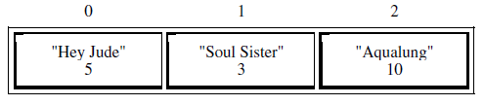

The call webMusicA.getDownloadInfo("Aqualung") returns a reference to the object in position 2 of the list.

The call webMusicA.getDownloadInfo("Happy Birthday") returns null because there areno DownloadInfo objects with that title in the list.

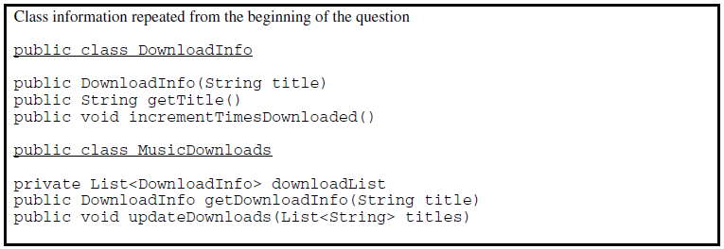

Complete method getDownloadInfo below.

/** Returns a reference to the DownloadInfo object with the requested title if it exists.

* @param title the requested title

* @return a reference to the DownloadInfo object with the

* title that matches the parameter title if it exists in the list;

* null otherwise.

* **Postcondition**:

* - no changes were made to downloadList.

*/

public DownloadInfo getDownloadInfo(String title)

1. Write the MusicDownloads method updateDownloads, which takes a list of song titles as a parameter. For each title in the list, the method updates downloadList, either by incrementing the download count if a DownloadInfo object with the same title exists, or by adding a new DownloadInfo object with that title and a download count of 1 to the end of the list. When a new DownloadInfo object is added to the end of the list, the order of the already existing entries in downloadList remains unchanged.

For example, suppose variable webMusicB refers to an instance of MusicDownloads and that the table below represents the contents of the instance variable downloadList.

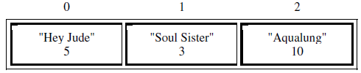

Assume that the variable List<String> songTitles has been defined and contains the following entries.

{"Lights", "Aqualung", "Soul Sister", "Go Now", "Lights", "Soul Sister"}

The call webMusicB.updateDownloads(songTitles) results in the following

downloadList with incremented download counts for the objects with titles of "Soul Sister" and "Aqualung". It also has a new DownloadInfo object with a title of "Lights" and a download count of 2, and another DownloadInfo object with a title of "Go Now" and a download count of 1. The order of the already existing entries remains unchanged.

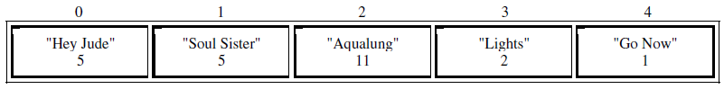

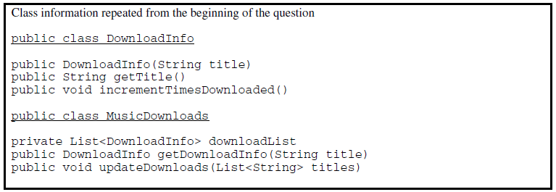

In writing your solution, you must use the getDownloadInfo method. Assume that

getDownloadInfo works as specified, regardless of what you wrote for part (a).

Complete method updateDownloads below.

/** Updates downloadList with information from titles.

* @param titles a list of song titles

* **Postcondition**:

* - there are no duplicate titles in downloadList.

* - no entries were removed from downloadList.

* - all songs in titles are represented in downloadList.

* - for each existing entry in downloadList, the download count is increased by

* the number of times its title appeared in titles.

* - the order of the existing entries in downloadList is not changed.

* - the first time an object with a title from titles is added to downloadList, it

* is added to the end of the list.

* - new entries in downloadList appear in the same order

* in which they first appear in titles.

* - for each new entry in downloadList, the download count is equal to

* the number of times its title appeared in titles.

*/

public void updateDownloads(List<String> titles )